Dokumentacija

////link sajta

Predmet : Web programiranje 1 Marko Mihajlović 153/19

Decembar 2021.

Sadržaj

Uvod 3

Korišćeni programski jezici i tehnologije 3

Opis funkcionalnosti 3

Template 3

Organizacija 4

Organizaciona šema 4

Mapa sajta 4

Stranice 5

Home 5

Rooms 6

About 7

Contact 8

Author 9

Kodovi 10

HTML 10

Index.html 10

Rooms.html 13

About.html 15

Contact.html 17

Author.html 20

CSS 21

Style.css 22

JavaScript 29

Main.js 29

# Uvod

## Korišćeni programski jezici i tehnologije

HTML, CSS, Bootstrap, JavaScript, Jquery, Gallery Lightbox Plugin

## Opis funkcionalnosti

* Responsive sajt, samostalno pisan kod
* ‘Sendvič’ dugme za otvaranje navigacije
* Dodavanje pozadinske boje header-a prilikom skrolovanja I smanjenje logo slike
* Dinamičko ispisivanje navigacije
* ‘Progres’ skrolovanja stranice
* Dinamičko ispisivanje servisa
* Dinamičko ispisivanje galerije(uz pugin)
* Dinamičko ispisivanje soba
* Validacija forme
* Dinamičko ispisivanje footer-a
* ‘Show more/less’ najčešćih pitanja
* Slajder na početnoj strani

## Template

Nije korišćen template, kod je samostalno pisan, ideja je preuzeta sa komercijalnih sajtova i template-a.

# Organizacija

## Organizaciona šema

Svakoj stranici je moguće pristupiti sa svih stranica.

## Mapa sajta

<urlset xmlns="http://www.sitemaps.org/schemas/sitemap/0.9">

<url>

<loc>index.html</loc>

<lastmod>2019-06-12</lastmod>

<changefreq>weekly</changefreq>

<priority>1</priority>

</url>

<url>

<loc>rooms.html</loc>

<lastmod>2019-06-12</lastmod>

<changefreq>monthly</changefreq>

<priority>0.9</priority>

</url>

<url>

<loc>contact.html</loc>

<lastmod>2019-06-12</lastmod>

<changefreq>yearly</changefreq>

<priority>0.8</priority>

</url>

<url>

<loc>about.html</loc>

<lastmod>2019-06-12</lastmod>

<changefreq>yearly</changefreq>

<priority>0.8</priority>

</url>

<url>

<loc>author.html</loc>

<lastmod>2019-06-12</lastmod>

<changefreq>yearly</changefreq>

<priority>0.2</priority>

</url>

</urlset>

## Stranice

### Home

Na ovoj stranici prikazan je header(ispisan iz js-a, isti na svim stranicama), footer(ispisan iz js-a, isti na svim stranicama), slajder(klikom na strelice menja se slika),dinamički ispis servica, dinamički ispis galerije(klikom na sliku otvara se galerija-plugin), dinamički ispis pitanja(klikom na pitanja, prikazuje se njegov odgovor),prelaskom misa preko slika Iz sekcije food, slike menjaju mesto, prelaskom misa preko logo slike, logo se rotira za +360 stepeni, a sklanjanjem za -360 stepeni.

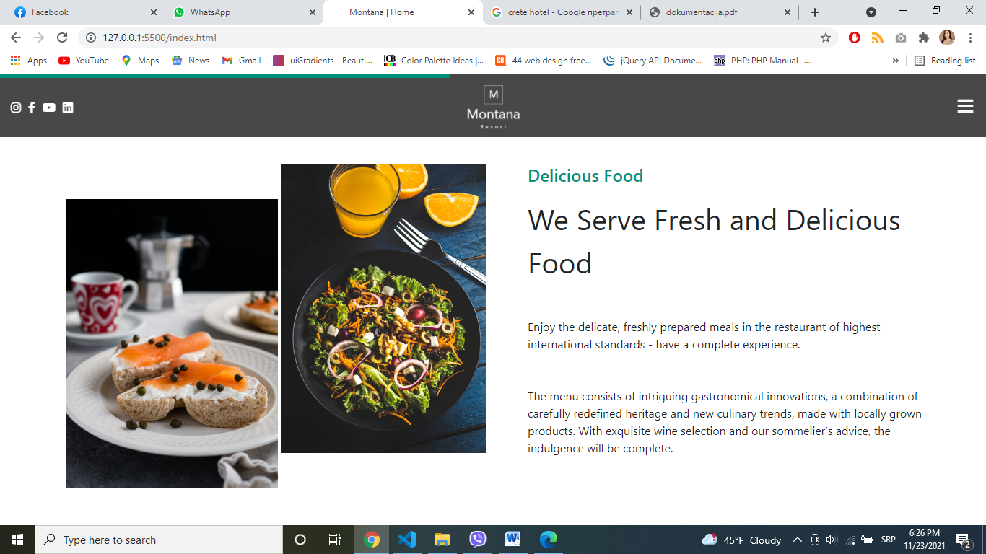

Prikaz ‘progresa’ prilikom skrolovanja

### Rooms

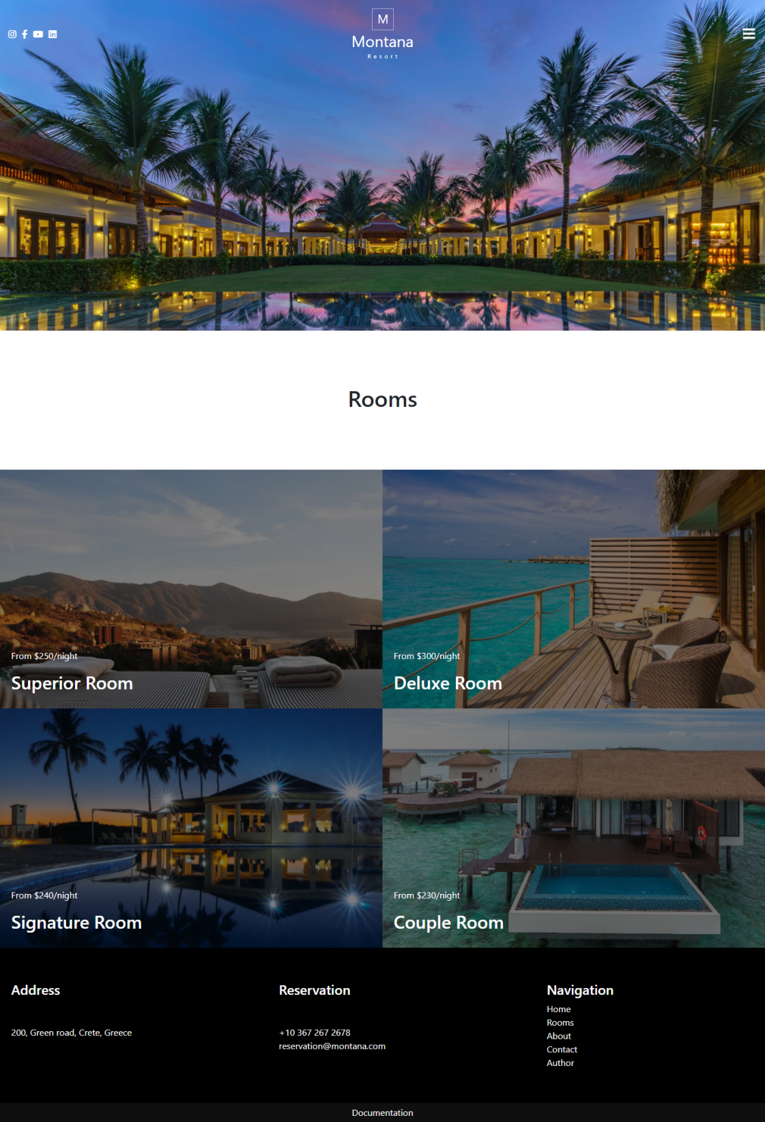

Na ovoj stranici prikazani su dinamički header I footer I dinamički ispis soba.

### About

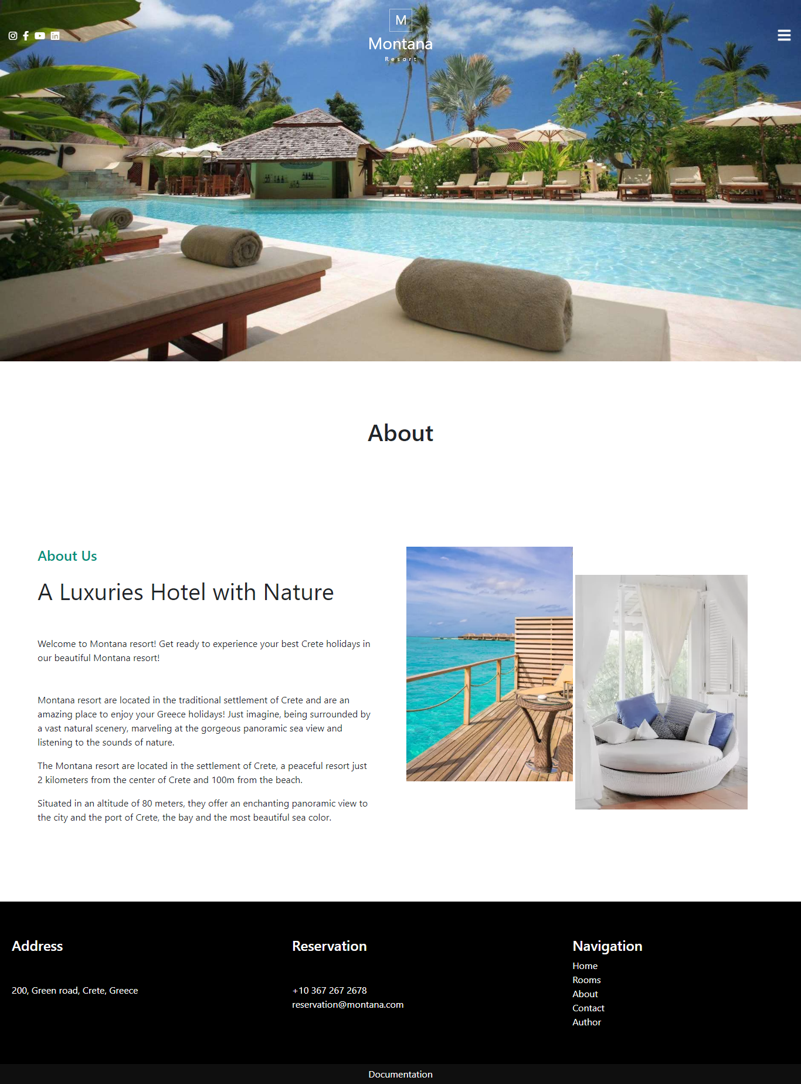

Na ovoj stranici prikazani su dinamički header I footer. Prelaskom mišem preko slika, one menjaju mesto.

### Contact

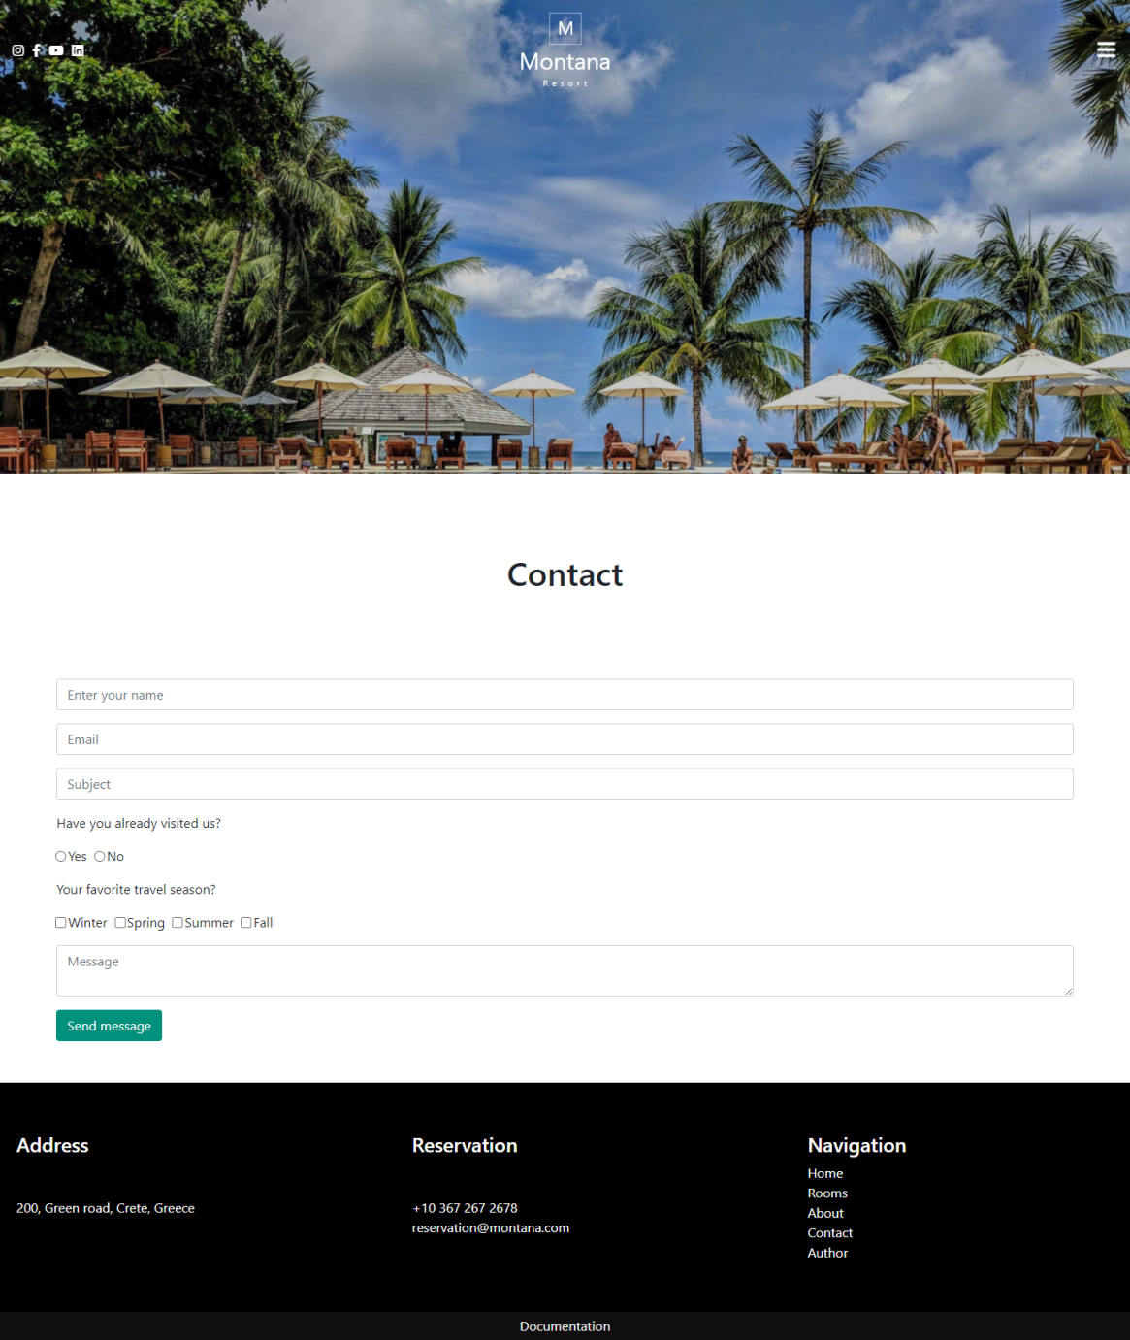

Na ovoj slici prikazani su dinamički header I footer. Klikom na dugme ‘Send message’, vrši se validacija podataka(funkciji za validaciju se šalju podaci, ukoliko su netacni, prikazuje se greška). Ukoliko je forma ispravno popunjena, ispisuje se poruka.

### Author

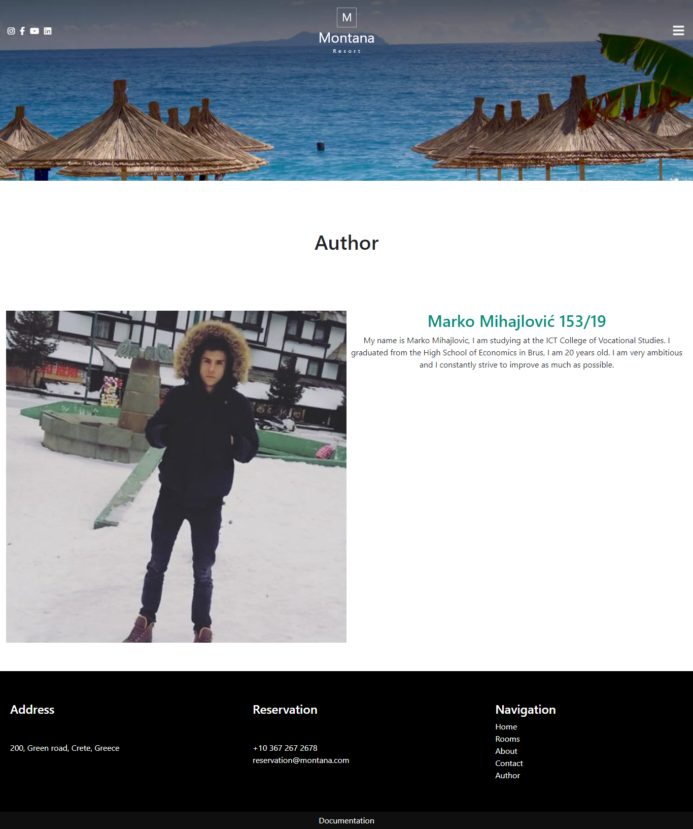

# Kodovi

## HTML

### Index.html

<!DOCTYPE html>

<html lang="en">

<head>

    <meta charset="UTF-8">

    <meta http-equiv="X-UA-Compatible" content="IE=edge">

    <meta name="viewport" content="width=device-width, initial-scale=1.0">

    <link href="https://cdn.jsdelivr.net/npm/bootstrap@5.1.3/dist/css/bootstrap.min.css" rel="stylesheet" integrity="sha384-1BmE4kWBq78iYhFldvKuhfTAU6auU8tT94WrHftjDbrCEXSU1oBoqyl2QvZ6jIW3" crossorigin="anonymous">

    <!-- Plugin -->

    <link rel="stylesheet"  href="lightGallery-1.10.0/dist/css/lightgallery.min.css" />

    <!-- Plugin -->

    <link rel="stylesheet" href="https://cdnjs.cloudflare.com/ajax/libs/font-awesome/5.15.1/css/all.min.css">

    <link rel="stylesheet" href="assets/css/style.css">

    <title>Montana | Home</title>

    <link rel="shortcut icon" href="assets/images/logo.ico" type="image/x-icon">

    <meta name="author" content="Marko Mihajlović">

    <meta name="description" content="A Luxuries Hotel with Nature. Get ready to experience your best Crete holidays in our beautiful Montana resort!"/>

    <meta name="keywords" content="Resort, Hotel, Montana resort, Crete, Vacation in Crete"/>

</head>

<body>

    <header>

        <div id="line"></div>

            <div id="top" class="d-flex justify-content-between align-items-center">

            </div>

    </header>

    <main>

        <div id="slider">

            <div id="prev"><a href="#" data-id="0" id="prevChevron" class="text-light"><i class="fas fa-chevron-left"></i></a></div>

            <div id="sliderImages">

            </div>

            <div id="heading">

                <h1 class="text-light fs-1">Montana resort</h1>

                <p class="text-light fs-2">Once a year go someplace you've never been before.</p>

            </div>

            <div id="next"><a href="#" data-id="0" id="nextChevron" class="text-light"><i class="fas fa-chevron-right"></i></a></div>

        </div>

        <div class="p-4 mt-5">

            <h2>Services</h2>

        </div>

        <div id="services" class="d-flex flex-wrap p-4 mb-5">

        </div>

        <div id="food" class="d-flex flex-wrap justify-content-between p-3">

            <div id="foodImages" class="food d-flex">

                <div>

                    <img class="img-fluid" src="assets/images/food1.png" alt="Sea food">

                </div>

                <div class="mt-5 mx-1">

                    <img class="img-fluid" src="assets/images/food2.png" alt="Hotel food">

                </div>

            </div>

            <div class="food px-5">

                <h4>Delicious Food</h4>

                <p class="mt-3 fs-1">We Serve Fresh and Delicious Food</p>

                <p class="mt-5">Enjoy the delicate, freshly prepared meals in the restaurant of highest international standards - have a complete experience.</p>

                <p class="mt-5">The menu consists of intriguing gastronomical innovations, a combination of carefully redefined heritage and new culinary trends, made with locally grown products. With exquisite wine selection and our sommelier’s advice, the indulgence will be complete.</p>

            </div>

        </div>

        <div id="gallery">

            <ul id="lightGallery" class="gallery p-0 d-flex flex-wrap">

                </ul>

        </div>

        <div id="testimonials">

        </div>

        <div id="questions">

            <div id="questinHeading">

                <h2>Frequently Asked Questions</h2>

            </div>

            <div id="listQuestions" class="question">

            </div>

        </div>

    </main>

    <!-- Responsive & Touch-Friendly jQuery Gallery Lightbox Plugin - lightGallery -->

    <!-- <script src="/path/to/cdn/jquery.min.js"></script> -->

    <script src="https://ajax.googleapis.com/ajax/libs/jquery/3.5.1/jquery.min.js"></script>

    <!-- Plugin -->

    <script src="lightGallery-1.10.0/dist/js/lightgallery-all.min.js"></script>

    <!-- Plugin -->

    <script src="assets/js/main.js" type="text/javascript"></script>

</body>

</html>

### Rooms.html

<!DOCTYPE html>

<html lang="en">

<head>

    <meta charset="UTF-8">

    <meta http-equiv="X-UA-Compatible" content="IE=edge">

    <meta name="viewport" content="width=device-width, initial-scale=1.0">

    <link href="https://cdn.jsdelivr.net/npm/bootstrap@5.1.3/dist/css/bootstrap.min.css" rel="stylesheet" integrity="sha384-1BmE4kWBq78iYhFldvKuhfTAU6auU8tT94WrHftjDbrCEXSU1oBoqyl2QvZ6jIW3" crossorigin="anonymous">

    <link rel="stylesheet" href="https://cdnjs.cloudflare.com/ajax/libs/font-awesome/5.15.1/css/all.min.css">

    <link rel="stylesheet" href="assets/css/style.css">

    <title>Montana</title>

    <link rel="stylesheet" href="assets/css/style.css">

    <title>Montana | Rooms</title>

    <link rel="shortcut icon" href="assets/images/logo.ico" type="image/x-icon">

    <meta name="author" content="Marko Mihajlović">

    <meta name="description" content="Escape to 298 modern, airy rooms at The Island hotel.Enjoy stylish surprises in your own residential retreat. Panoramic views of the Aegean sea"/>

    <meta name="keywords" content="Montana Resort, Superior Room, Deluxe Room, Signature Room, Couple Room"/>

</head>

<body>

    <header>

        <div id="line"></div>

            <div id="top" class="d-flex justify-content-between align-items-center">

            </div>

    </header>

    <main>

        <div id="slider">

            <img class="img-fluid" src="assets/images/cover3.jpg" alt="Image rooms">

        </div>

        <div class="text-center py-5 my-5">

            <h1>Rooms</h1>

        </div>

        <div id="rooms">

        </div>

    </main>

    <!-- Responsive & Touch-Friendly jQuery Gallery Lightbox Plugin - lightGallery -->

    <!-- <script src="/path/to/cdn/jquery.min.js"></script> -->

    <script src="https://ajax.googleapis.com/ajax/libs/jquery/3.5.1/jquery.min.js"></script>

    <script src="assets/js/main.js" type="text/javascript"></script>

</body>

</html>

### About.html

<!DOCTYPE html>

<html lang="en">

<head>

    <meta charset="UTF-8">

    <meta http-equiv="X-UA-Compatible" content="IE=edge">

    <meta name="viewport" content="width=device-width, initial-scale=1.0">

    <link href="https://cdn.jsdelivr.net/npm/bootstrap@5.1.3/dist/css/bootstrap.min.css" rel="stylesheet" integrity="sha384-1BmE4kWBq78iYhFldvKuhfTAU6auU8tT94WrHftjDbrCEXSU1oBoqyl2QvZ6jIW3" crossorigin="anonymous">

    <link rel="stylesheet" href="https://cdnjs.cloudflare.com/ajax/libs/font-awesome/5.15.1/css/all.min.css">

    <link rel="stylesheet" href="assets/css/style.css">

    <title>Montana</title>

    <link rel="stylesheet" href="assets/css/style.css">

    <title>Montana | About</title>

    <link rel="shortcut icon" href="assets/images/logo.ico" type="image/x-icon">

    <meta name="author" content="Marko Mihajlović">

    <meta name="description" content="Montana resort are located in the traditional settlement of Crete and are an amazing place to enjoy your Greece holidays!"/>

    <meta name="keywords" content="Hotel about, Hotel, Montana resort, Crete, Greece"/>

</head>

<body>

    <header>

        <div id="line"></div>

            <div id="top" class="d-flex justify-content-between align-items-center">

            </div>

    </header>

    <main>

        <div id="slider">

            <img class="img-fluid" src="assets/images/hotelImage.jpeg" alt="Image rooms">

        </div>

        <div class="text-center py-5 my-5">

            <h1>About</h1>

        </div>

        <div id="food" class="d-flex flex-wrap justify-content-between p-3">

            <div class="food px-5">

                <h4>About Us</h4>

                <p class="mt-3 fs-1">A Luxuries Hotel with Nature</p>

                <p class="mt-5">Welcome to Montana resort!

                    Get ready to experience your best Crete holidays in our beautiful Montana resort!</p>

                <p class="mt-5">Montana resort are located in the traditional settlement of Crete and are an amazing place to enjoy your Greece holidays! Just imagine, being surrounded by a vast natural scenery, marveling at the gorgeous panoramic sea view and listening to the sounds of nature.</p>

                <p>The Montana resort are located in the settlement of Crete, a peaceful resort just 2 kilometers from the center of Crete and 100m from the beach.</p>

                <p>Situated in an altitude of 80 meters, they offer an enchanting panoramic view to the city and the port of Crete, the bay and the most beautiful sea color.</p>

            </div>

            <div id="foodImages" class="food d-flex">

                <div>

                    <img class="img-fluid" src="assets/images/about1.webp" alt="Sea food">

                </div>

                <div class="mt-5 mx-1">

                    <img class="img-fluid" src="assets/images/about2.webp" alt="Hotel food">

                </div>

            </div>

        </div>

    </main>

    <script src="https://ajax.googleapis.com/ajax/libs/jquery/3.5.1/jquery.min.js"></script>

    <script src="assets/js/main.js" type="text/javascript"></script>

</body>

</html>

### Contact.html

<!DOCTYPE html>

<html lang="en">

<head>

    <meta charset="UTF-8">

    <meta http-equiv="X-UA-Compatible" content="IE=edge">

    <meta name="viewport" content="width=device-width, initial-scale=1.0">

    <link href="https://cdn.jsdelivr.net/npm/bootstrap@5.1.3/dist/css/bootstrap.min.css" rel="stylesheet" integrity="sha384-1BmE4kWBq78iYhFldvKuhfTAU6auU8tT94WrHftjDbrCEXSU1oBoqyl2QvZ6jIW3" crossorigin="anonymous">

    <link rel="stylesheet" href="https://cdnjs.cloudflare.com/ajax/libs/font-awesome/5.15.1/css/all.min.css">

    <link rel="stylesheet" href="assets/css/style.css">

    <title>Montana</title>

    <title>Montana | Contact</title>

    <link rel="shortcut icon" href="assets/images/logo.ico" type="image/x-icon">

    <meta name="author" content="Marko Mihajlović">

    <meta name="description" content="Keep in Touch! We are always glad to hear from you! So don’t step back."/>

    <meta name="keywords" content="Hotel Contact, Hotel, Montana resort, Crete, Send message"/>

</head>

<body>

    <header>

        <div id="line"></div>

            <div id="top" class="d-flex justify-content-between align-items-center">

            </div>

    </header>

    <main>

        <div id="slider">

            <img class="img-fluid" src="assets/images/cover4.jpg" alt="Image rooms">

        </div>

        <div class="text-center py-5 my-5">

            <h1>Contact</h1>

        </div>

        <div id="contact">

            <form action="#" method="#">

                <div class="input-group mb-3">

                    <input id="name" type="text" class="form-control" placeholder="Enter your name">

                </div>

                <p class="text-danger d-none">Correct format eg. John Doe</p>

                <div class="input-group mb-3">

                    <input id="email" type="text" class="form-control" placeholder="Email" >

                </div>

                <p class="text-danger d-none">Correct format eg. johndoe@gmail.com</p>

                <div class="input-group mb-3">

                    <input id="subject" type="text" class="form-control" placeholder="Subject">

                </div>

                <p class="text-danger d-none">Subject has 1 word minimum (capital letter,minimum 2 letters)</p>

                <div id="radio" class="input-group mb-3 d-flex align-items-center flex-wrap-wrap">

                    <div class="heading"><p>Have you already visited us?</p></div>

                    <input type="radio" name="answer" value="yes"> <span>Yes</span>

                    <input type="radio" name="answer" value="no"> <span>No</span>

                </div>

                <p class="text-danger d-none">You have to choose answer!</p>

                <div id="checkbox" class="input-group mb-3 checkbox d-flex align-items-center flex-wrap-wrap">

                    <div class="heading"><p>Your favorite travel season?</p></div>

                    <input type="checkbox" name="chb" value="winter"><span>Winter</span>

                    <input type="checkbox" name="chb" value="spring"><span>Spring</span>

                    <input type="checkbox" name="chb" value="summer"><span>Summer</span>

                    <input type="checkbox" name="chb" value="fall"><span>Fall</span>

                </div>

                <p class="text-danger d-none">You have to select 1 answer minimum!</p>

                <div class="input-group">

                    <textarea id="message" placeholder="Message" class="form-control" aria-label="With textarea"></textarea>

                </div>

                <p class="text-danger d-none">Message has 5 words minimum</p>

                <div class="btn-group mt-3">

                    <button type="button" id="buttonMessage" class="btn text-light">Send message</button>

                </div>

                <p class="text-success d-none" id="messageText">Message sent!</p>

                <div class="mt-3 d-none" id="messageInfo">

                </div>

            </form>

        </div>

    </main>

    <!-- <script src="/path/to/cdn/jquery.min.js"></script> -->

    <script src="https://ajax.googleapis.com/ajax/libs/jquery/3.5.1/jquery.min.js"></script>

    <script src="assets/js/main.js" type="text/javascript"></script>

</body>

</html>

### Author.html

<!DOCTYPE html>

<html lang="en">

<head>

    <meta charset="UTF-8">

    <meta http-equiv="X-UA-Compatible" content="IE=edge">

    <meta name="viewport" content="width=device-width, initial-scale=1.0">

    <link href="https://cdn.jsdelivr.net/npm/bootstrap@5.1.3/dist/css/bootstrap.min.css" rel="stylesheet" integrity="sha384-1BmE4kWBq78iYhFldvKuhfTAU6auU8tT94WrHftjDbrCEXSU1oBoqyl2QvZ6jIW3" crossorigin="anonymous">

    <link rel="stylesheet" href="https://cdnjs.cloudflare.com/ajax/libs/font-awesome/5.15.1/css/all.min.css">

    <link rel="stylesheet" href="assets/css/style.css">

    <title>Montana</title>

    <title>Montana | Author</title>

    <link rel="shortcut icon" href="assets/images/logo.ico" type="image/x-icon">

    <meta name="author" content="Marko Mihajlović">

    <meta name="description" content="Marko Mihajlović"/>

    <meta name="keywords" content="Marko Mihajlović"/>

</head>

<body>

    <header>

        <div id="line"></div>

            <div id="top" class="d-flex justify-content-between align-items-center">

            </div>

    </header>

    <main>

        <div id="slider">

            <img class="img-fluid" src="assets/images/contact.webp" alt="Image rooms">

        </div>

        <div class="text-center py-5 my-5">

            <h1>Author</h1>

        </div>

        <div class="container-fluid d-flex flex-wrap my-5 justify-content-center">

            <div class="col-12 col-md-6 text-center my-2">

                <img src="assets/images/author.jpg" class="img-fluid" alt="Author image">

            </div>

            <div class="col-12 col-md-6 my-2 text-center">

                <h2>Marko Mihajlović 153/19</h2>

            </div>

        </div>

    </main>

    <script src="https://ajax.googleapis.com/ajax/libs/jquery/3.5.1/jquery.min.js"></script>

    <script src="assets/js/main.js" type="text/javascript"></script>

</body>

</html>

## CSS

### Style.css

h2{

    color: #00917c;

}

ul{

    margin: 0px;

    padding: 0px;

}

#slider{

    width: 100%;

    position: relative;

}

#sliderImages{

    width: 100%;

    position: relative;

    z-index: 75;

}

#prev,#next{

    position: absolute;

    top: 50%;

    font-size: 50px;

    color: #fff;

    z-index: 80;

    bottom: 45%;

}

#prev{

    left: 20px;

}

#next{

    right: 20px;

}

#heading{

    position: absolute;

    top: 40%;

    z-index: 80;

    text-align: center;

    left: 10%;

    right: 10%;

}

header{

    width: 100%;

    position: fixed;

    top: 0px;

    z-index: 99;

    transition-duration: 0.5s;

}

#services p{

    text-align: justify;

}

#services .service{

    box-shadow: 0 15px 30px 0 rgb(167, 167, 167);

    width: 23%;

}

#food{

    margin: 90px 0px;

}

.food{

    width: 50%;

    padding: 10px;

}

#gallery{

    width: 100%;

}

ul{

    list-style-type: none;

}

#gallery li{

    width: 25%;

}

.scroll{

    background-color: rgba(29, 29, 29, 0.808);

    transition-duration: 0.5s;

}

#logo{

    transition-duration: 0.5s;

}

.logoSize{

    width: 75px;

    transition-duration: 0.5s;

}

#top{

    width: 100%;

    padding: 10px;

}

#line{

    height: 5px;

    width: 0px;

    background-color: #00917c;

}

header ul li a{

    color: #fff;

}

.hide{

    display: none;

}

#hamburger ul{

    position: absolute;

    top: 87px;

    left: 0px;

    right: 0px;

    padding: 0px 20px;

    text-align: right;

}

#hamburger ul li{

    margin: 10px 0px;

    padding: 10px 0px;

}

#hamburger ul li a{

    text-decoration: none;

}

a:hover{

    color: #fff;

}

#services i{

    color: #00917c;

}

#food h4{

    color: #00917c;

}

#networks a{

    text-decoration: none;

    margin: 0px 5px;

}

#questions{

    background-color: #00917c;

    padding: 60px 40px;

    display: flex;

    flex-wrap: wrap;

    justify-content: space-between;

    align-items: center;

}

#questions h2{

    color: #fff;

}

.oneQuestion{

    border-bottom: 0.5px solid #00000048;

    position: relative;

    padding: 10px;

}

.oneQuestion i{

    position: absolute;

    top: 10px;

    right: 10px;

}

#questinHeading{

    width: 30%;

}

#listQuestions{

    width: 60%;

}

footer{

    background-color: #000;

    color: #fff;

}

footer p{

    margin-top: 50px;

}

#networks,#hamburger{

    width: 30%;

}

#hamburger{

    text-align: right;

}

.footerDoc{

    width: 100%;

    background-color: #0f0f0f;

    text-align: center;

    padding: 5px;

}

footer a{

    color: #fff;

    text-decoration: none;

}

.footerDiv{

    padding: 30px 20px;

    margin: 30px 0px;

    width: 30%;

}

#services{

    justify-content: space-between;

}

#rooms{

    width: 100%;

    display: flex;

    flex-wrap: wrap;

}

.room{

    width: 50%;

    position: relative;

}

.roomDesc{

    position: absolute;

    left: 20px;

    bottom: 20px;

}

.roomDesc h2,.roomDesc p{

    color: #fff;

}

.room img{

    filter: brightness(0.5);

}

#contact{

    width: 90%;

    margin: 0px auto;

    margin-bottom: 50px;

}

.btn{

    background-color: #00917c;

}

.reverse{

    flex-direction: row-reverse;

}

/* responsive */

@media screen and (max-width:1024px){

    #service,#food{

        justify-content: center!important;

    }

    #services .service{

        width: 45%;

    }

    .food{

        width: 100%;

    }

    #questinHeading{

        text-align: center;

        margin: 20px 0px;

    }

    #questions{

        justify-content: center;

        padding: 20px 10px;

    }

    #questinHeading,#listQuestions{

        width: 90%;

    }

    #networks{

        display: none;

    }

    .food{

        justify-content: center;

    }

    .room{

        width: 100%;

    }

    .mobileScroll{

        background-color: rgba(29, 29, 29, 0.808);

        transition-duration: 0.5s;

    }

}

@media screen and (max-width:600px){

    #services .service{

        width: 90%;

    }

    #gallery li{

        width: 50%;

    }

    #heading{

        display: none;

    }

    #prev,#next{

        font-size: 25px;

    }

    #logo{

        width: 50px;

    }

    #hamburger ul{

        top: 66px;

    }

    .footerDiv{

        width: 80%;

        margin: 20px 0px;

    }

    footer p{

        margin: 5px 0px;

    }

    #services{

        justify-content: center;

    }

}

## JavaScript

### Main.js

$(document).ready(function(){

    menu()

    footer()

    let url=location.href;

    if(url.indexOf("index.html")!=-1){

        slider()

        $("#nextChevron").click(nextSlide)

        $("#prevChevron").click(previousSlide)

        services()

        gallery()

        questions()

    }

    if(url.indexOf("rooms.html")!=-1){

        rooms()

    }

    if(url.indexOf("contact.html")!=-1){

        $("#buttonMessage").click(message)

    }

    if(url.indexOf("about.html")!=-1 || url.indexOf("index.html")!=-1){

        document.getElementById("foodImages").addEventListener("mouseover",function(){

            document.getElementById("foodImages").classList.add("reverse")

        })

        document.getElementById("foodImages").addEventListener("mouseout",function(){

            document.getElementById("foodImages").classList.remove("reverse")

        })

    }

    $("#logo").hover(

        function(){

            $("#logo").css({

                transform: "rotate(+360deg)"

            },1500)

    },

    function(){

        $("#logo").css({

            transform: "rotate(-360deg)"

        },1500)

    })

})

$(window).scroll(function(){

    var pixels=$(document).scrollTop();

    var windowHeight=$(document).height()-$(window).height();

    var progress=pixels/windowHeight*100;

    if(window.pageYOffset>20){

        $("header").addClass("scroll")

        $("header #hamburger ul").addClass("scroll")

        $("#logo").addClass("logoSize")

    }

    else{

        $("header").removeClass("scroll")

        $("header #hamburger ul").removeClass("scroll")

        $("#logo").removeClass("logoSize")

    }

  $("#line").css("width", progress + "%");

})

var sliderImages=['slider1.webp','slider2.webp'];

var sliderAlt=['Hotel image 1','Hotel image 2'];

function slider(){

    var print=""

    for(let s in sliderImages){

        print+=`<img class="sliderImages img-fluid" src="assets/images/${sliderImages[s]}" alt="${sliderAlt[s]}"/>`

    }

    $("#sliderImages").html(print)

    $(".sliderImages").addClass("d-none")

    $(".sliderImages").first().removeClass("d-none")

}

function nextSlide(e){

    e.preventDefault()

    var current=this.dataset.id

    next=parseInt(current)+1

    prev=parseInt(current)-1

    if(current==sliderImages.length-1){

        $(".sliderImages").addClass("d-none")

        $(".sliderImages")[0].classList.remove("d-none")

        $("#nextChevron").attr("data-id",0)

        $("#prevChevron").attr("data-id",prev)

    }

    else{

        $(".sliderImages").addClass("d-none")

        $(".sliderImages").get(next).classList.remove("d-none")

        $("#nextChevron").attr("data-id",next)

        $("#prevChevron").attr("data-id",next)

    }

}

function previousSlide(e){

    e.preventDefault()

    var current=this.dataset.id

    next=parseInt(current)+1

    prev=parseInt(current)-1

    if(current==0){

        $(".sliderImages").addClass("d-none")

        $(".sliderImages")[sliderImages.length-1].classList.remove("d-none")

        $("#nextChevron").attr("data-id",next)

        $("#prevChevron").attr("data-id",sliderImages.length-1)

    }

    else{

        $(".sliderImages").addClass("d-none")

        $(".sliderImages")[prev].classList.remove("d-none")

        $("#nextChevron").attr("data-id",prev)

        $("#prevChevron").attr("data-id",prev)

    }

}

var linkText=['Home','Rooms','About','Contact','Author']

var linkHref=['index.html','rooms.html','about.html','contact.html','author.html']

function menu(){

    let print=''

    print+=`<div id="networks">

        <ul class="d-flex">

            <li><a href="https://www.instagram.com" target="_blank"><i class="fab fa-instagram"></i></a></li>

            <li><a href="https://www.facebook.com" target="_blank"><i class="fab fa-facebook-f"></i></a></li>

            <li><a href="https://www.youtube.com" target="_blank"><i class="fab fa-youtube"></i></a></li>

            <li><a href="https://www.linkedin.com/" target="_blank"><i class="fab fa-linkedin"></i></a></li>

        </ul>

    </div>

    <div id="logo">

    <a class="text-decoration-none" href="index.html"><img class="img-fluid" src="assets/images/logo.webp"/></a>

    </div>

    <div id="hamburger">

        <a href="#" id="hamburger" class="hamburger text-light"><i class="fas fa-bars fs-4 mx-2"></i></a>

        <ul class="hide nav">`

        for(let i=0;i<linkText.length;i++){

            print+=`<li><a href="${linkHref[i]}">${linkText[i]}</a></li>`

        }

    print+=`</ul>

    </div>`

    $('#top').html(print)

    var bar=$("#hamburger> a")

    bar.click(function(e){

        e.preventDefault()

        var sideNav=$("#hamburger ul")

        sideNav.toggle(

            function(){

            $(this).find("ul").slideDown()

        },

            function(){

            $(this).find("ul").slideUp()

            })

        })

}

function services(){

    var icons=['fas fa-hiking','fas fa-suitcase-rolling','fas fa-globe-europe','fas fa-plane'];

    var text=['Accommodations in Montana resort are specialised on hikers and offer guided tours, equipment rental, a snack and detailed proposals for tours as a standard feature.','Montana resort allow you to store luggage at the hotel  before check-in and after check-out free of charge.','Your choices for your next trip are endless with our different properties throughout the world and, even better, you get to collect double the mileage reward with our Frequent Flyer partners.','We offer you the possibility of free transportation from the airport to the hotel and back.']

    var heading=['Hiking ','Suitcase','World Round','Travel with Plane']

    let print=''

    for(let i=0;i<icons.length;i++){

        print+=`<div class="px-3 my-3 py-5 service">

            <i class="${icons[i]} fs-1"></i>

            <h3 class="mt-4">${heading[i]}</h3>

            <p class="mt-4">${text[i]}</p>

        </div>`

    }

    $("#services").html(print)

}

function gallery(){

    var images=['gallery1.jpg','gallery2.jpg','gallery3.jpg','gallery4.jpg','gallery5.jpg','gallery6.jpg','gallery7.jpg','gallery8.jpg']

    let print=''

    images.forEach(el=>{

        print+=`<li data-title="Gallery image" data-desc="Gallery image" data-responsive-src="assets/images/${el}" data-src="assets/images/${el}"> <a href="#"> <img class="img-fluid" alt="Gallery image" src="assets/images/${el}" /> </a> </li>`

    })

    $("#lightGallery").html(print)

    $("#lightGallery").lightGallery();

}

function questions(){

    var questions=['How many rooms can I book at once?','How do I pay for our accommodation?','Is it possible to check in earlier?','Do the rates include breakfast?']

    var answers=['You can book as many rooms as are available for selected period.','It depends on the room payment conditions. In most cases you will pay directly at the hotel after your arrival. ','It is sometimes possible to check in early however this is subject to availability. To ensure your room is ready upon arrival, we recommend you reserve the room one night in advance.','All rates include breakfast.']

    let print=''

    for(let i=0;i<questions.length;i++){

        print+=`<div class="oneQuestion">

        <a href="#" data-id="${i}" class="text-light showMore asnwerEvent text-decoration-none">

            <h3>${questions[i]}</h3>

            <p class="answer d-none">${answers[i]}</p>

            <i class="fas fa-chevron-down fs-3"></i>

            <i class="fas fa-chevron-up fs-3 d-none"></i>

            </a>

        </div>`

    }

    document.getElementById("listQuestions").innerHTML+=print

    $(".asnwerEvent").click(function(e){

        e.preventDefault()

        var id=this.dataset.id

        if($(this).hasClass("showMore")){

            document.getElementsByClassName("answer")[id].classList.remove("d-none")

            document.getElementsByClassName("fa-chevron-down")[id].classList.add("d-none")

            this.classList.remove("showMore")

            document.getElementsByClassName("fa-chevron-up")[id].classList.remove("d-none")

        }

        else{

            document.getElementsByClassName("answer")[id].classList.add("d-none")

            document.getElementsByClassName("fa-chevron-down")[id].classList.remove("d-none")

            document.getElementsByClassName("fa-chevron-up")[id].classList.add("d-none")

            this.classList.add("showMore")

        }

    })

}

function footer(){

    var footer=document.createElement("footer")

    footer.setAttribute("class","d-flex flex-wrap justify-content-between flex-wrap");

    $("body").append(footer)

    var footerAdress=document.createElement("div")

    var footerReservation=document.createElement("div")

    var footerNavigation=document.createElement("div")

    var footerDoc=document.createElement("div")

    footerAdress.setAttribute("class","footerDiv")

    footerReservation.setAttribute("class","footerDiv")

    footerNavigation.setAttribute("class","footerDiv")

    footerDoc.setAttribute("class","footerDoc")

    var headingAddress=document.createElement("h4")

    var headingReservation=document.createElement("h4")

    var headingNavigation=document.createElement("h4")

    var textAddress=document.createElement("p")

    var textReservation=document.createElement("p")

    var footerDocText=document.createElement("a")

    headingAddress.innerText="Address"

    headingReservation.innerText="Reservation"

    headingNavigation.innerText="Navigation"

    footerDocText.innerText="Documentation"

    footerDocText.setAttribute("href","documentation.pdf")

    textAddress.innerText="200, Green road, Crete, Greece"

    textReservation.innerText="+10 367 267 2678 \n reservation@montana.com"

    var ul=document.createElement("ul")

    for(let i=0;i<linkText.length;i++){

        var li=document.createElement("li");

        ul.append(li)

        var aElement=document.createElement("a")

        li.append(aElement)

        aElement.text=linkText[i]

        aElement.setAttribute("href",linkHref[i])

    }

    $("body").append(footer)

    footer.append(footerAdress)

    footer.append(footerReservation)

    footer.append(footerNavigation)

    footer.append(footerDoc)

    footerAdress.append(headingAddress)

    footerReservation.append(headingReservation)

    footerNavigation.append(headingNavigation)

    footerNavigation.append(ul)

    footerDoc.append(footerDocText)

    footerAdress.append(textAddress)

    footerReservation.append(textReservation)

}

function rooms(){

    var roomsImages=['room1.webp','room2.webp','room3.webp','room4.webp']

    var roomsTitle=['Superior Room','Deluxe Room','Signature Room','Couple Room']

    var roomPrice=[250,300,240,230]

    var print=''

    for(let i=0;i<roomsTitle.length;i++){

        print+=`<div class="room">

            <div class="image">

                <img class="img-fluid" src="assets/images/${roomsImages[i]}"/>

            </div>

            <div class="roomDesc">

                <p>From $${roomPrice[i]}/night</p>

                <h2>${roomsTitle[i]}</h2>

            </div>

        </div>`

    }

    $("#rooms").html(print)

}

function validator(inputValue,regExpr){

    var br=0

    if(!regExpr.test(inputValue.value)){

        br++

        inputValue.parentElement.nextElementSibling.classList.remove('d-none')

    }

    else{

        inputValue.parentElement.nextElementSibling.classList.add('d-none')

    }

    return br

}

function message(){

    var email=document.getElementById("email")

    var name=document.getElementById("name")

    var subject=document.getElementById("subject")

    var message=document.getElementById("message")

    var radio=$("input[name='answer']:checked")

    var chb=$("input[name='chb']:checked")

    var regEmail=/^\w+([\.-]?\w+)*@\w+([\.-]?\w+)*(\.\w{2,4})+$/;

    var regSubject=/^[A-ZŽĐŠĆČ][a-zžđšćč]{2,}(\s[a-zžđšćč]{2,}){0,2}$/;

    var regName=/^[A-ZŽĐŠĆČ][a-zžđšćč]{2,}(\s[A-ZŽĐŠĆČ][a-zžđšćč]{2,}){1,2}$/;

    var err=0

    err+=validator(email,regEmail)

    err+=validator(subject,regSubject)

    err+=validator(name,regName)

    if(message.value.split(" ").length<5){

        message.parentElement.nextElementSibling.classList.remove('d-none')

        err++

    }

    else{

        message.parentElement.nextElementSibling.classList.add('d-none')

    }

    if(radio.val()==undefined){

        $("#radio").next().removeClass('d-none')

    }

    else{

        $("#radio").next().addClass('d-none')

    }

    if(chb.length==0){

        $("#checkbox").next().removeClass('d-none')

    }

    else{

        $("#checkbox").next().addClass('d-none')

    }

    var br=1

    if(err==0){

        var print=`Your message: ' ${message.value} ' was sent successfully!`

        this.parentElement.nextElementSibling.classList.remove('d-none')

        $("#messageText").html(`${name.value}, thank you for contacting us!`)

        print+=`<p>Hope to see you in `

        for(let c of chb){

            if(br==chb.length){

                print+=`${c.value}!`

            }

            else{

                print+=`${c.value}, `

            }

            br++

        }

        print+=`</p>`

        $("#messageInfo").removeClass("d-none")

        $("#messageInfo").html(print)

        $("input[type='text']").val("")

        $("textarea").val("")

        $("input[type=radio]").prop('checked', false);

        $("input[type=checkbox]").prop('checked', false);

    }

}